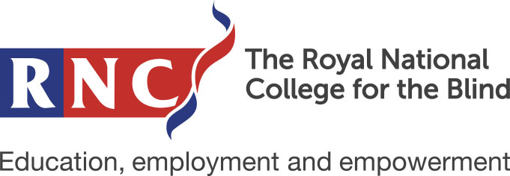

Have a Go Weekend Application Form

Saturday 19th and Sunday 20th February 2022

The Royal National College for the Blind (RNC)
Venns Lane, Hereford HR1 1DT

If you need any help completing this form, please contact the Student Enquiries Team on 01432 376 621 or email info@rnc.ac.uk

- The RNC Have a Go weekend is a free event for young people aged 13 to17 years.
- The weekend runs from 11am on Saturday and finishes at approximately 3pm Sunday. It involves one overnight stay in free accommodation for the young person and any accompanying adults.
- We would expect the young person to be accompanied by one responsible adult. Additional adults are welcome, as are siblings.
- We find that young people have a great time, enjoy getting to know each other and making new friends. Their programme is completely separate from that of the accompanying adults, which gives the latter an enjoyable break and the young people a taste of independence.

- The Adults Programme involves several useful Information and advice sessions, and adults are free to enjoy their spare time, maybe exploring Hereford city centre.

- All attendees are provided with Saturday lunch, an evening meal on Saturday evening with breakfast and lunch on Sunday.

- The young people’s programme often includes an off-campus activity, whilst the adults remain on the College grounds.

- Our experienced support team will make sure the young people are kept safe and entertained throughout their stay.

Young Person Details
Full name:
Known as:
Home Address
(including postcode):

Date of Birth:

Accompanying Adult Details
Relationship to Young Person:
Full name:
Known as:
Home Address
(including postcode):

Phone Number:
Email Address:

Additional Accompanying Adult Details (if applicable)
Relationship to Young Person:
Full name:
Known as:
Home Address
(including postcode):

Phone Number:
Email Address:

Medical Information
Is the young person registered blind or partially sighted?

What is the eye condition(s)?

How does this affect the young person?

Are there any additional medical conditions, illnesses, injures or allergies that you think we need to be made aware of?

Please list any medication prescribed which the young person will need take during the weekend

Is the young person able to self-medicate?
If no, what assistance is required?

Mobility Information:
Does the young person use any mobility aid? E.g. long cane or guide dog.
Is the young person a wheelchair user?
Please provide any information that you think may be relevant

Additional Information:
What is their preferred reading format? E.g. standard print, large print, braille, audio.
Does the young person have any special dietary requirements?

Name and Address of School or College:

Please state any VI Organisations that you are a member of?

What are your interests and hobbies?

How did you hear about the Have a Go weekend?

Parental Consent for Medical Attention:
In the event that any young person is injured during any activities, and their parent / guardian cannot be contacted, medical treatment may need to be administered.
I give consent for my child to receive medical attention. | Yes / No
Signature: | Date:
Print Full Name:

Parental Consent for Photography:
During the weekend, RNC may be taking photographs and video footage which may be used for promotional literature, including prospectus, website and social media.
I am happy for my child to be filmed and photographed. | Yes / No
Signature: | Date:
Print Full Name:

Please note that by completing this form your details will be held on our student record system and will be used for the purpose of administration, guidance and monitoring. As part of administration process we will send you information and communication relating to your application and admission. Please see our Privacy Policy on our website www.rnc.ac.uk/privacy-policy

Please return this form to:

Student Recruitment Team
The Royal National College for the Blind
Venns Lane, Hereford, HR1 1DT

Or email info@rnc.ac.uk

